Contact Manager
Ideation Phase
Brainstorm & Idea Prioritization

Date | 17/02/2026
Team ID | 69aa79c9c9a3758259e17b91
Project Name | Contact Manager
Maximum Marks | 4 Marks

Brainstorm & Idea Prioritization
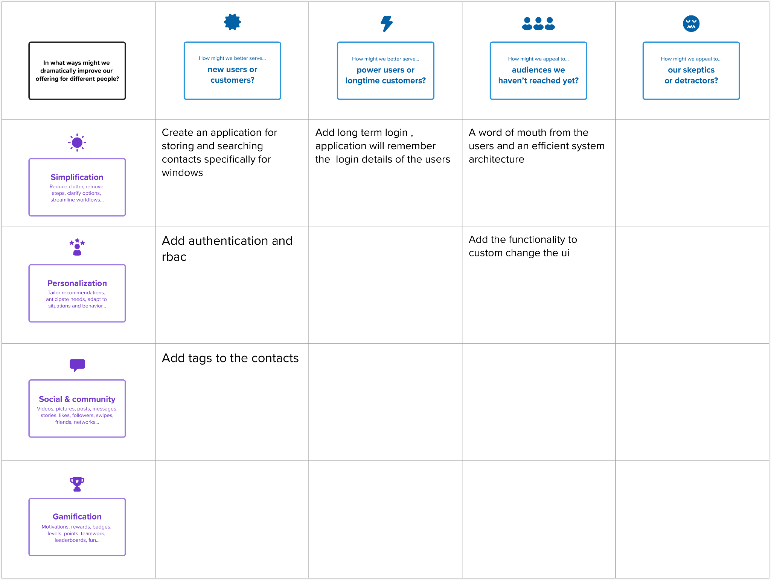

Ste 2 : Idea Prioritization
